KENDRIYA VIDYALAYA, TAMENGLONG
S.A.-1 ,2015-16

Name : …………………… Class : III Time : 2 Hours
Roll No. ………………….. Subject : English Date :

COMPETENCIES

Reading(20) |  |  |  | Writing(40) |  |  |  |  |  |  |  |  |  | Total (60)
Unseen Passage (10) |  | Seen Passage (10) |  | Prose & Poetry (10) |  | Grammar (10) |  | Creative writing (10) |  | Spellings (5) |  | Handwriting  (5)
Marks | Grade | Marks | Grade | Marks | Grade | Marks | Grade | Marks | Grade | Marks | Grade | Marks | Grade | Marks | Grade

Invigilator’s sign. Examiner’s sign.

R E A D I N G
Q.1- Read the following passage. Answer the following questions in one word or one sentence.
Sonu loved the little butterfly. It was so pretty. It had brown spots on its yellow wings. But it looked sad in Sonu’s hand. Sonu wanted it to be happy. “Go,” said Sonu, “fly away!”.
He let the butterfly go. It sat on the red rose. It flew to the peach tree and then sailed on a lotus leaf. It flew merrily from flower to flower.

- Who loved the little butterfly?
__________________________________________________________________________
ii) Who was so pretty?
__________________________________________________________________________
iii) Which colour spots did the butterfly have?
__________________________________________________________________________
iv) Who was having yellow colour wings?
__________________________________________________________________________
v) Who looked sad in Sonu’s hand?
__________________________________________________________________________
vi) Which flower mentioned in the passage?
__________________________________________________________________________
vii) What is the name of the tree in the passage?
__________________________________________________________________________
viii) Butterfly sailed on _____________________________________
ix) What is the past tense of the word
want _____________________
- Write the opposite of the word
happy _____________________
Q.2- - Read the following passage. Answer the following questions in one word or one sentence.
Father: Salim, why are you wearing sherwani to school today?

Salim: We are doing a play on Chacha Nehru, today. Today is 14th November and we are going to stage a play on Chacha Nehru. Nehru was fond of children. so, we celebrate this day as children’s day. We call him as Chacha.

Ahmed: I am going to play the role of Gandhi. Gandhi was called ‘Bapu’. The father of Nation.

- Who is going to play the role of Nehru? __________________________________________________________________________
ii) Who is going to play the role of Gandhi? __________________________________________________________________________
iii) Who is wearing Sherwani? __________________________________________________________________________
iv) Who are going to stage a play? __________________________________________________________________________
v) Where they are playing a stage? __________________________________________________________________________
vi) Whose birthday is going to be celebrated? __________________________________________________________________________
vii) On which day we celebrate Chacha’s birthday? __________________________________________________________________________
viii) Who is known as Chacha?
__________________________________________________________________________
ix) Who was fond of children? __________________________________________________________________________
x) Who is known as father of Nation?
__________________________________________________________________________
W R I T I N G
Answer any 5 of the following questions.

- What do you see around you during the day ? __________________________________________________________________________________________________________________________
2) what is the dinner of a worm ?
__________________________________________________________________________________________________________________________
3) name the flowers growing in the magic garden ?
_________________________________________________________________________________________________________________________
4) Why was the little fish unhappy?
______________________________________________________________
______________________________________________________________
5) Where does the balloon man stand?
______________________________________________________________________________________________________________________
6) Why was Nina worried?
___________________________________________________________________________________________________________________________
7) What do birds think of people?
______________________________________________________________________________________________________________________
GRAMMAR
Do as directed .
a) Write the plurals of the following:
1. Balloon = ________________ 2. Tomato =_______________

b ) Write the pas tense of the following:
1. Pick =_________________ 2. help = ______________
c) Fill in the blanks with the right word from the box.
Flowers Water Cows
- A glass of ________________________

- A bunch of ________________________

- A herd of ________________________

d) Write the opposites of the following.
1. Sit ____________ 2. Up ____________
e) Choose the odd man and encircle it. One has been done for you
Ex. Pen, pencil, sketch, water bottle
Turnip, Tomato, Parrot, Radish
C R E A T I V E W R I T I N G
a) Write a few things about yourself .
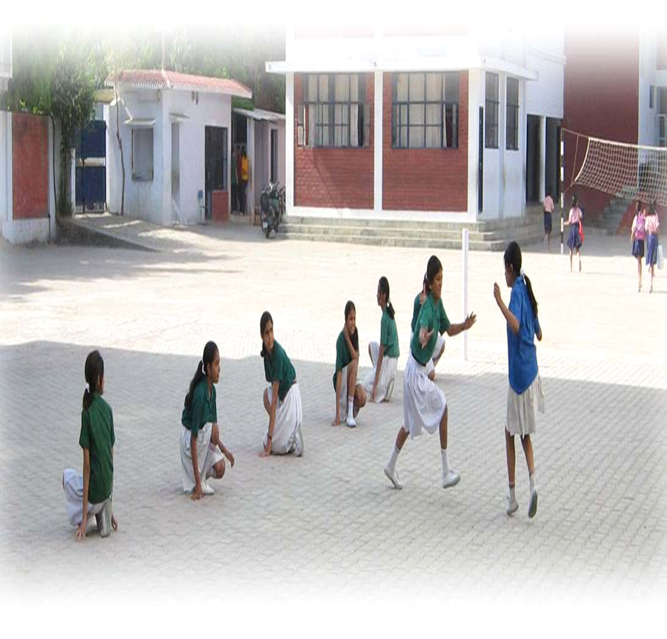
__________________________________________________________________________________________________________________________________________________________________________________________________________________________________________________________________________________________________________________________________________________________________________________________________________________
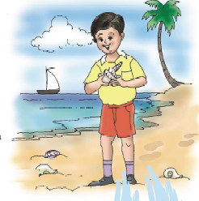
b)Write a few sentenses about trees.

___________________________________________________________________________________________________________________________________________________________________________________________________________________________________________________________________________________________________________________________________________________________________________________________________________________________________________________________________________________________________________________________

SPELLI N G

- Re-arrange the following word to make a meaningful word.

- ikpn =___________________________

- weyoll =__________________________

2) Make two words from one word
a. In side ______________ ________________
b. sunlight ______________ ________________
c. goodmorning ______________ ________________

H A N D W R I T I N G

Copy the following neatly .

Unity is strength. As long as we are united, we can solve any problem. The moment we get separated, we become weak. Tagore also said that the world should not be divided into fragments, but should be treated as a single unit.
_______________________________________________________________________________________________________________________________________________________________________________________________________________________________________________________________________________________________________________________________________________________________________________________________________________________________________________________________________________________________________________________________

